Упражнения по теме «Еда»

Exercises on the topic "Food"

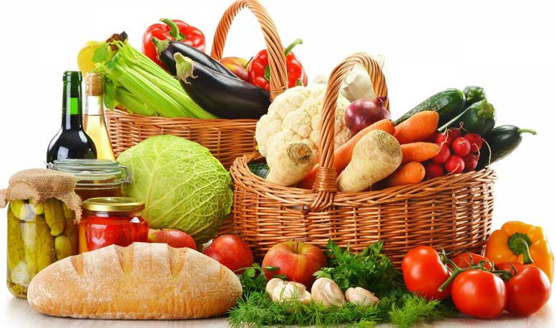
Упражнения идут от простых к более сложным.
Упражнение 1. Распределите названия продуктов по следующим категориям. Цифра обозначает количество слов в категории.
Chocolate, potato, tea, steak, pear, carrot, garlic, cake, pineapple, broccoli, wine, water, peach, coffee, ice cream, tomato, ham, watermelon, cookies
MEAT (2):
DRINKS (4):
DESSERTS (4):
FRUIT (4):
VEGETABLES (5):
Упражнение 2. Look at the picture and say true or false.
- THERE IS SOME COFFEE
- THERE ARE SOME TOMATOES
- THERE ISN’T ANY MILK
- THERE IS SOME TEA
- THERE AREN’T ANY EGGS
- THERE ARE SOME COOKIES
- THERE IS SOME BACON
- THERE IS SOME BREAD
- THERE ARE SOME MUSHROOMS
- THERE ARE SOME PANCAKES
- THERE IS A CABBAGE
- THERE ARE SOME APPLES
Кстати, вы также можете повторить тему SOME / ANY / NO, и выполнить упражнения по этой теме.
Упражнение 3. Назовите продукт по описанию.
- You need me to make a sandwich or toast. – B_________
- I’m yellow or white. I’m made from milk. People like me on their pizza. — C___________
- People eat us fried, boiled or scrambled. — E_______
- I’m a very popular fast food with a sausage in the middle. — H______________
- I’m a long yellow fruit. — B_____________
- Rabbits love this orange vegetable. – C_______________
На нашем сайте есть также загадки про еду, овощи и фрукты.
Упражнение 4. Ответьте на вопросы.
- How often do you drink milk?
- How often do you eat at restaurants?
- What’s your favorite food?
- What food do you hate?
- What’s your favorite ice-cream flavor?
- What’s the strangest thing you’ve ever eaten?
- Are you allergic to any food?
- What’s your favorite drink?
Упражнение 5.
- Name 5 fruits.
- Name 5 vegetables.
- Name 5 drinks.
- Name 3 sweet foods.
- Name 3 salty foods.
- Name 3 bitter foods.
Упражнение 6. Соотнесите идиомы и их значения.
1. Chew the fat  2. Mouth is watering  3. Half-baked idea  4. Your finger in the pie  5. Cook your goose  6. Eat dirt  7. Cry over spilled milk  8. Hungry as a horse  9. Go bananas | A. to be involved in something  B. to make someone want to eat or drink  C. to hurt or ruin someone  D. to act humble  E. to not think about or study carefully  F. chat  G. to complain about something that has happened  H. able to eat a lot  I. to become too excited and behave crazily
Ответы.
Exercise 1.
MEAT: steak, ham.
DRINKS: tea, wine, water, coffee.
DESSERTS: chocolate, cake, ice cream, cookies.
FRUIT: pear, pineapple, peach, watermelon.
VEGETABLES: potato, carrot, garlic, broccoli, tomato.
Exercise 2. 1 F, 2 T, 3 T, 4 F, 5 T, 6 F, 7 F, 8 T, 9 T, 10 F, 11 T, 12 T
Exercise 3. 1 – bread, 2 — cheese, 3- eggs, 4 – hot-dog, 5 banana, 6 carrot
Exercise 4. Your own answers.
Exercise 5. Your own answers.
Exercise 6. 1 – F, 2 – B, 3 – E, 4 – A, 5 – C, 6 – D, 7 – G, 8 – H, 9 — I

